BE CAREFUL WHAT YOU PRAY FOR!
A report of my two weeks in Darwin
by Dr Bill Day for St Luke’s Anglican Community, Maylands, WA.
Before my departure to Darwin on August 21st this year, many friends said to me, “Have a good holiday!” However, my travels to Darwin up to four times a year (at my own expense) are to continue my work with Aboriginal people that began back in 1970. In Darwin there is much “unfinished business”, in particular saving the urban land won for Aboriginal people that is now threatened as the city grows and the land becomes valuable to developers. Indeed, the One Mile Dam community on a 3.5 hectare lease won in 1979 is now almost within the CBD of Darwin.
On my latest trip to Darwin, I did things a little differently. For a start, I asked the community of St Luke’s in Maylands to pray for me during the service on the Sunday prior to my departure. Our priest, Father Jack Thomson, called me to the front after the service and members of the congregation laid their hands upon me as Jack prayed and anointed me with holy oil. At the time, I felt the Spirit filling me with strength for the journey, enabling me to set off in faith not knowing what lay ahead, as I had no set plans other than to collect copies of my 1994 book, Bunji: a story of the Gwalwa Daraniki Movement, that were stored in Darwin.
I was soon to find that the way through the wilderness was well prepared! Firstly, I received an email from residents of the inner suburb of Ludmilla who were concerned that the nearby bushland, thought to be safely in Aboriginal hands, was now rezoned for a huge light industry estate. They asked if I would be visiting Darwin some day, and if so, could I attend their inaugural meeting to form an action group. They also hoped to work with the Aboriginal traditional owners and wanted my advice on how this could be done.
On my arrival I hit the ground running, arranging for an Aboriginal representative and myself to meet the residents on-site to discuss what could be done. It was election time in the Territory, so a few aspiring politicians also attended. During my two weeks in Darwin, the fledgling group held four meetings, and I was given the job of drawing up a petition – firstly a draft, to be discussed, and then the real thing which already has dozens of signatures.
The NT elections were held on Saturday August 25th during my stay and I became fully immersed in the campaign of a Larrakia man, Daniel Fejo, the son of the late Rev Wally Fejo of Nungalinya College. It was a very emotional moment for me, thinking how proud the old people would have been to see one of their people now standing for parliament, at great personal and financial cost. Back in 1971 I had first met the Larrakia elders living under sheets of rusty corrugated iron on vacant Crown land in the suburbs, with no recognition that Darwin was built on their land. My book tells the story of their journey for justice. There was also a meeting of residents at the Bagot community that I attended and renewed my friendship with the people on the 22ha lease at Knuckeys Lagoon.

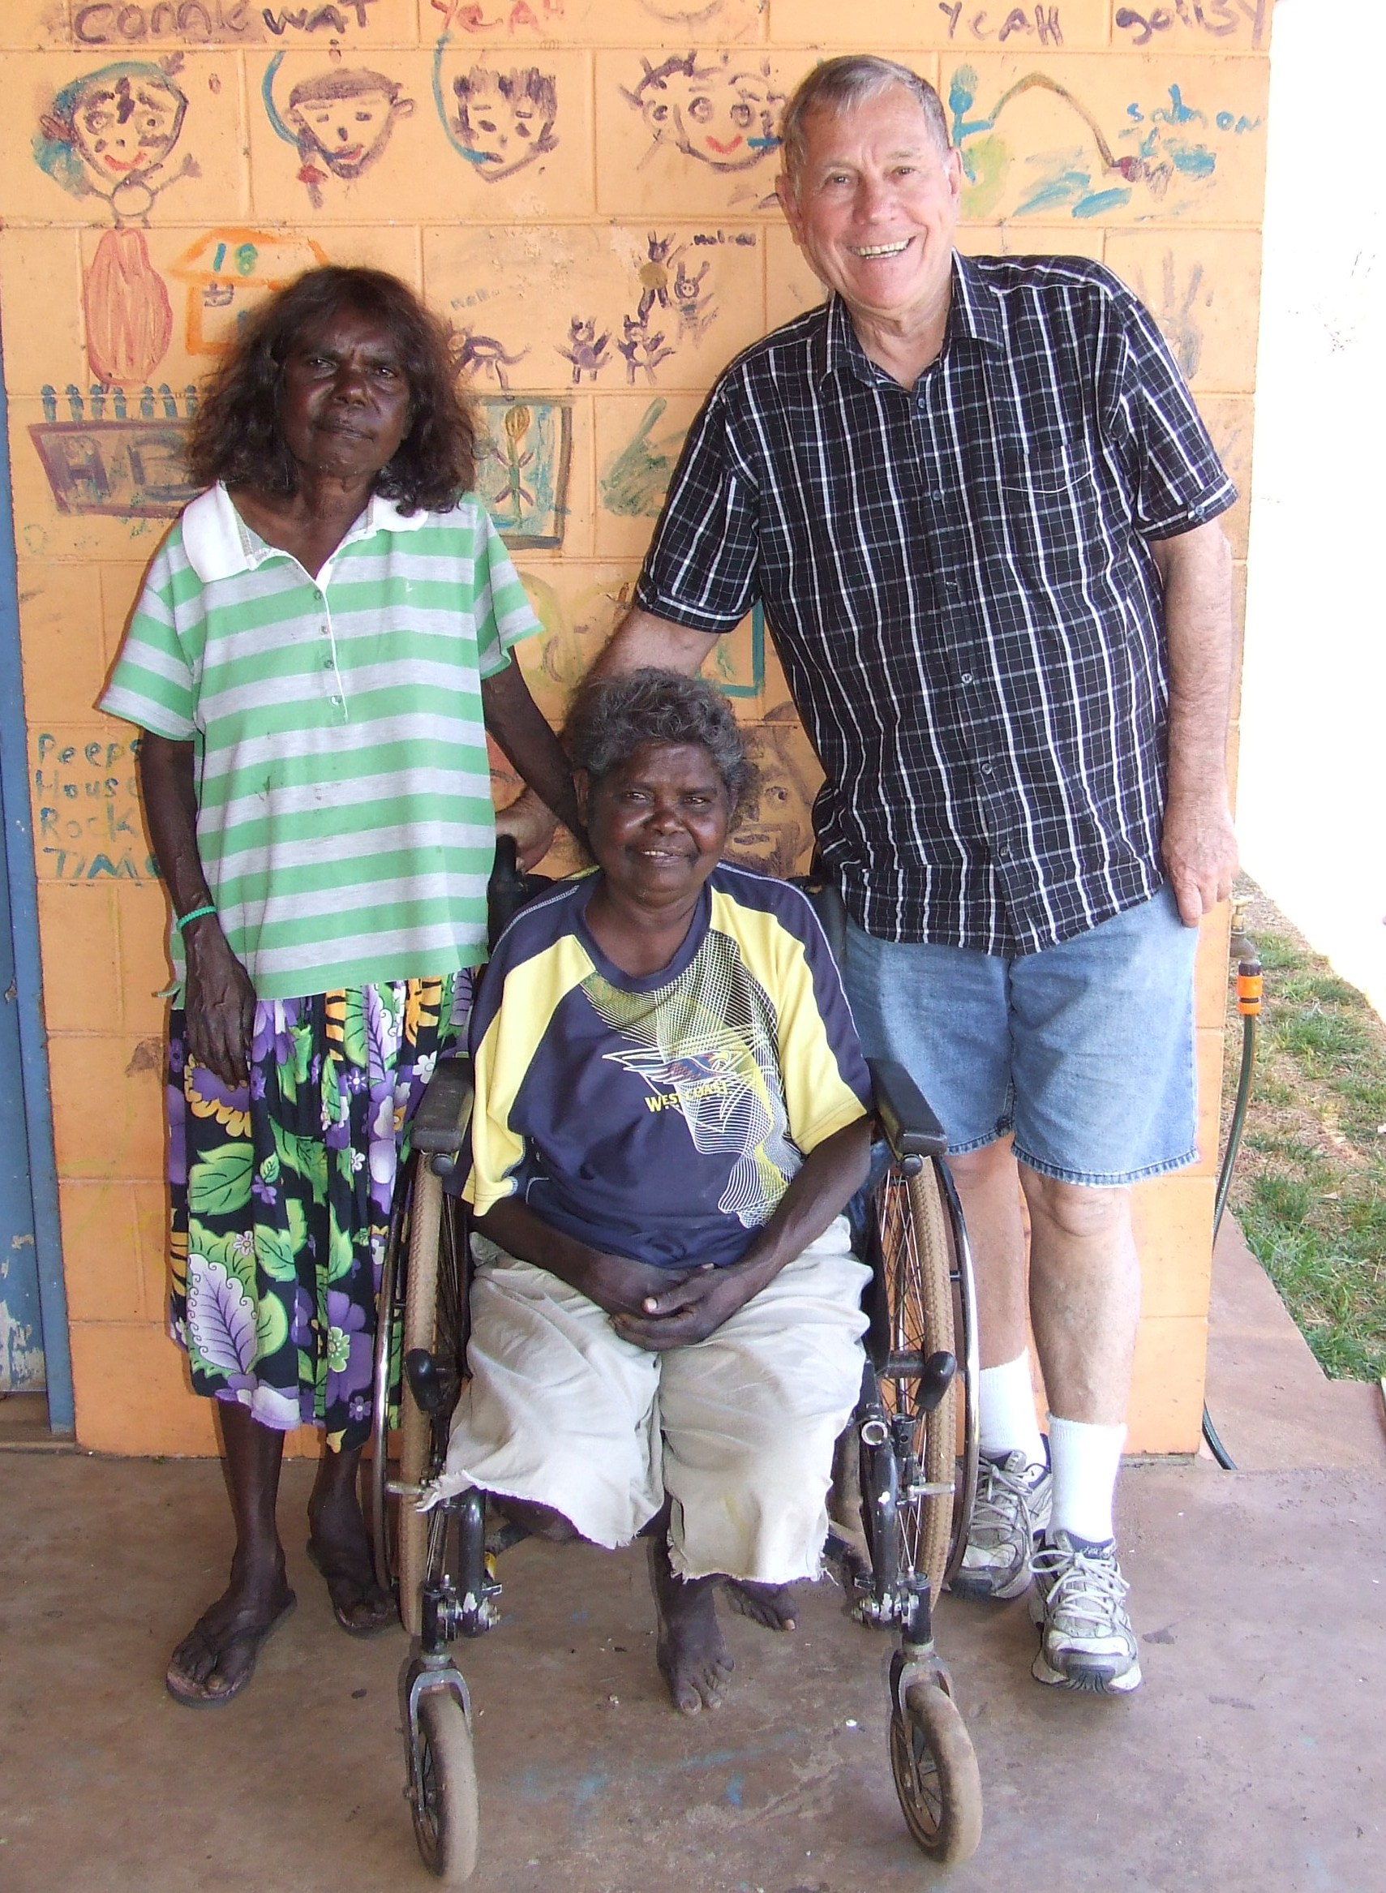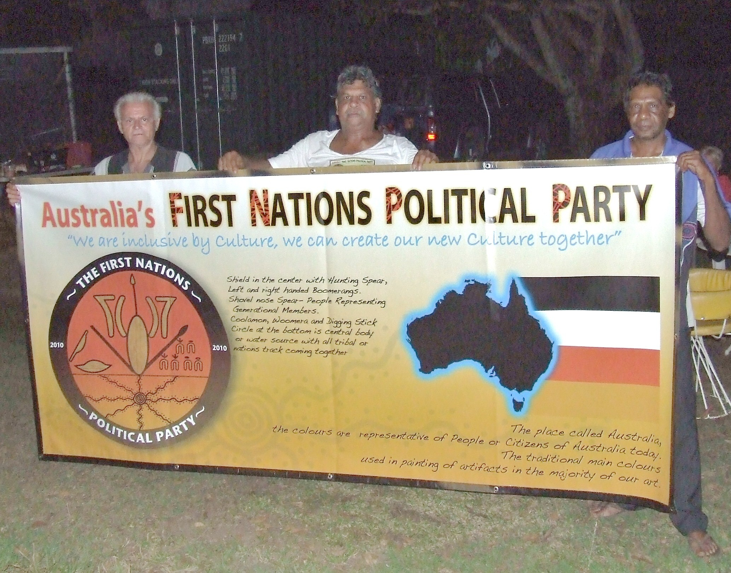
Above: Bill at Knuckeys Lagoon. Right: Daniel’s election banner.

At One Mile Dam, I met Miriam Ashley, the wife of actor David Gulpilil. Miriam lives in a house on the land with no running water or electricity. Her house is one of two houses that have been without power for more than eight months. The authorities refuse to repair the faulty underground power line because they say it would be “too expensive” to do so. However, Centrelink still take automatic rent payments from her pension. Meanwhile, around the corner is situated the ultra-modern Convention Centre, Wave Pool and other luxury developments in the prestigious Waterfront Precinct, financed with funds diverted from Federal GST “closing the gap” grants.
On my agenda were also the usual visits to prisoners in jail, including a young man who has been incarcerated for 6 years, mostly in maximum security, for a conviction as a 15-year-old boy, sentenced at 19 by a judge who had something to prove and on the strength of evidence of the complainant, contested by every other witness. More details of this case can be found on my website, www.drbilldayanthropologist.com The notorious Berrimah prison is full of Aboriginal people, so the young man says he is not lonely, apart from missing the growing years of his little daughter. Sadly, neither am I ever short of people to visit!
Unfortunately, no-one has ever offered to pay me for my work in Darwin, so returning to the NT is dependent on finances which in turn are dependent upon me getting work in the Pilbara, where I earn my bread and butter (before Centrelink takes their cut from my pension). That brings me to another blessing that occurred: A friend dropped me off at shopping centre in a part of Darwin I seldom visit because I was on my way to the resident’s action group meeting that evening (to be held at the Trailer Boat Club, beside the sea, beneath the palms, watching the sunset). While walking through the area, known as Parap, my mobile rang. It was the director of Northern Manganese Ltd, a small minerals exploration company offering me a few days work in late September surveying a tenement out of Port Hedland. The director presumed he was talking to me in Perth and explained that he is usually based in Kalgoorlie but is now working in the Northern Territory. I replied that I was in Darwin all week, and asked where he was ringing from. He answered, “From my office in Parap”. Astonished, I replied, “I am in Parap right now. Where is your office? I’ll come to see you.” He answered, “On the first floor above the LJ Hooker sign, at the roundabout.”
“Look out your window, and you will see me standing on the corner,” I said. And so it was that my finances have been taken care of in the near future!
As the fortnight drew to a close, my friend Vikki Riley, who does good work with asylum seekers in detention centres around Darwin, arranged for me to meet with the librarian at the NT State Library, in the Parliament House building, a palace worthy of a foreign dictator. There we made a convincing case for a display on the land rights struggle of the 1970s, a history little known to the transient Darwin population. Hopefully, the 1,000-signature petition to the Queen we prepared in 1972 could be lent by the National Archives to augment other records held in Darwin, including a display of samples of our 64 newsletters published from 1971 to 1984. Vikki had just successfully curated an exhibition of art from the detention centres, which I also attended.

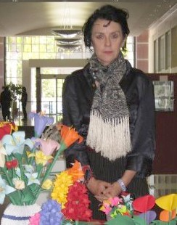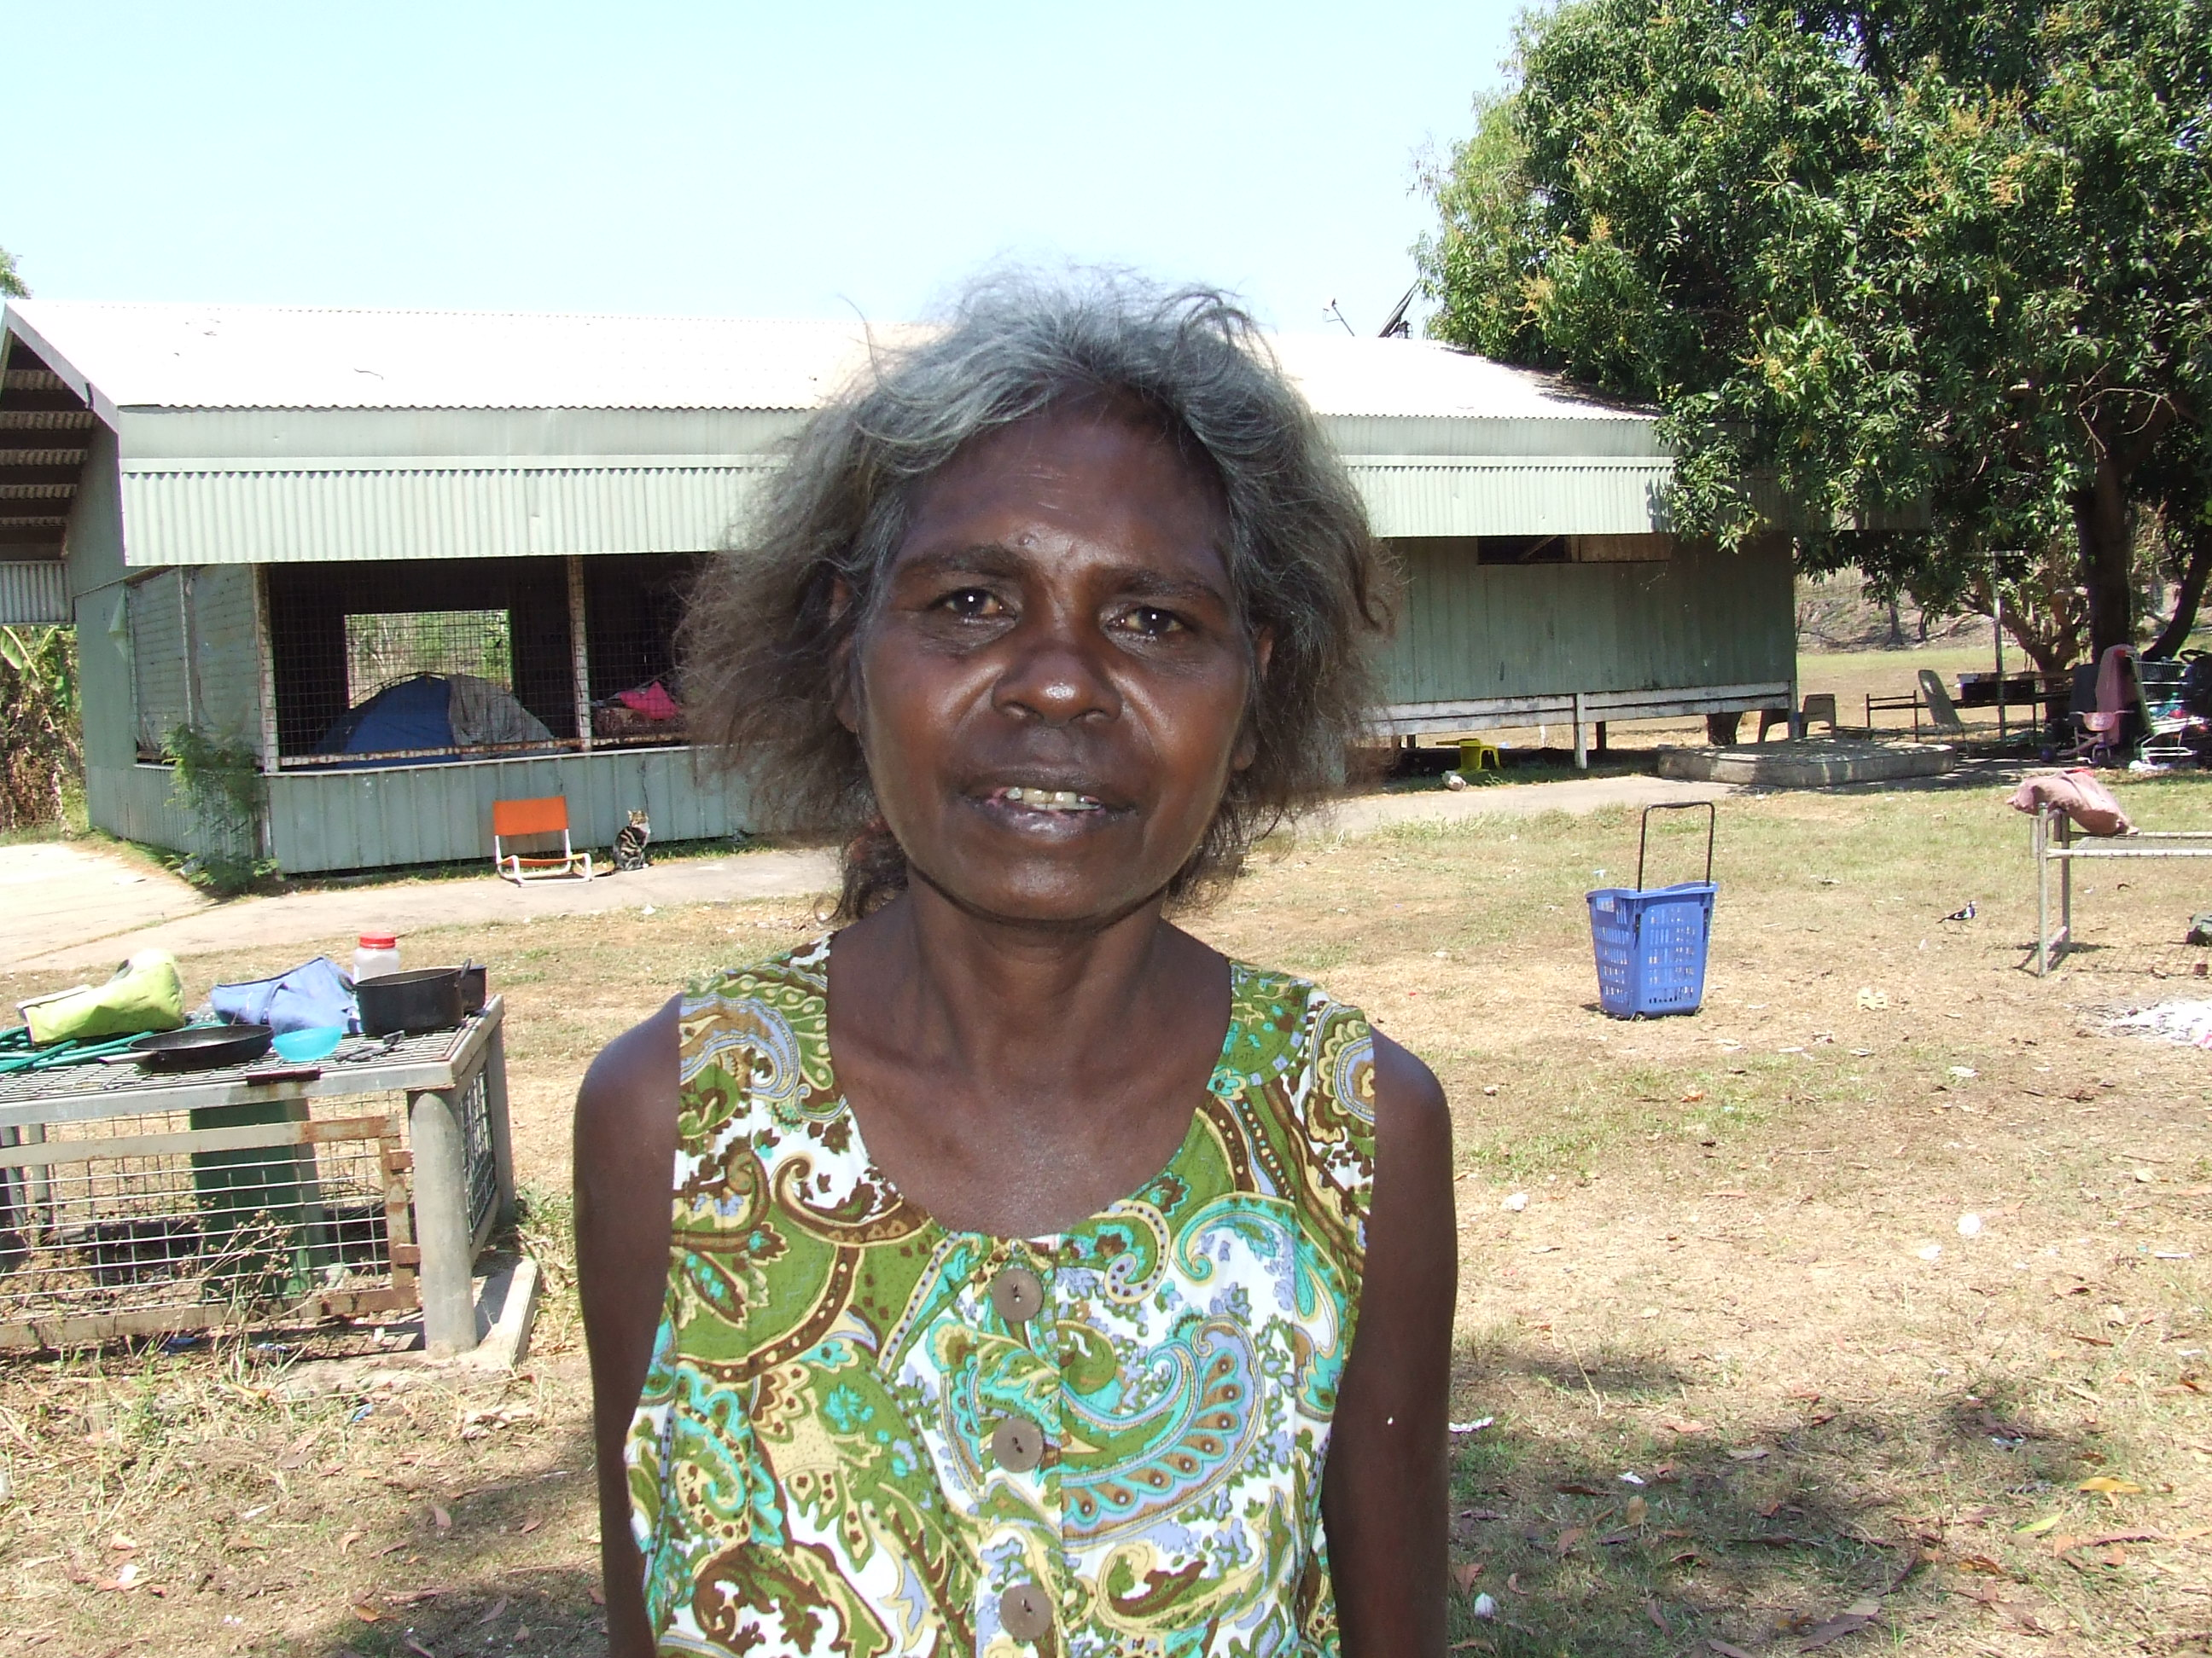
Above: Vikki Riley with refugee art. Died, 10 September 2012, RIP.
Right: Miriam Ashley outside her house at One Mile Dam in Darwin.

Spiritually, I was refreshed during my two weeks by attending the Uniting Church in Nightcliff with Pastor Basil Schild bringing a strong social justice message. The weather was also invigorating, not the usual “build up” humidity. Additionally, I was very blessed by having central accommodation with the kindly grandmother of the lad in prison. Accommodation in Darwin is very expensive and in short supply.
When it was time to go, the wonderful people God put in my path were already asking plaintively, “When are you coming back?” They made me feel guilty that I could not answer them with a definite date, but these days much valuable work can be done on the computer. Finally, like the healed leper, I now return to St Luke’s to say thank you for your prayers – rest assured they have been very effective!

Bill Day
Sunday,
9th September 2012

Postscript: My friend Vikki Riley was struck by a car on September 10th the day after I wrote this report, and died in the Royal Darwin Hospital. Her funeral was held in Darwin on September 17th. She lived a life in the likeness of Christ, inspired by her Christian faith. I have added her photograph (above).

